NEPAL COLLEGE OF INFORMATION TECHNOLOGY
Balkumari, Lalitpur
Affiliated to Pokhara University

LAB REPORT FOR DATABASE MANAGEMENT SYSTEM


LAB REPORT 8: FAMILIARIZATION WITH SOME CLAUSES

Submitted by: Submitted to:
Name: Arpan Adhikari Er. Simanta Kasaju
Roll No.: 231309
BE-CE (3rd SEM)

S. N | LAB TOPIC | DATE | REMARKS
1. | INTRODUCTION TO SQL | 10th Nov
2. | FAMILIARIZATION WITH DDL COMMAND | 17th Nov
3. | FAMILIARIZATION WITH VARIOUS CONSTRAINTS IN SQL | 24th Nov
4. | FAMILIARIZATION WITH DML COMMANDS (INSERT, UPDATE, DELETE) | 1st Dec
5. | FAMILIARIZATION WITH DCL COMMANDS (GRANT, REVOKE) | 8th Dec
6,7. | FAMILIARIZATION WITH TCL COMMAND AND DQL COMMANDS | 30th Dec
8. | FAMILIARIZATION WITH SOME CLAUSES (SELECT, FROM, WHERE, GROUP BY, HAVING, ORDER BY,BETWEEN, NOT BETWEEN), ALIAS OPERATION (AS OPERATOR), CASE, NESTED QUERY COMMANDS (IN, NOT IN, HAVING, ALL, ANY, EXIST), Union. | 30th Dec

LAB 8: FAMILIARIZATION WITH SOME CLAUSES (SELECT, FROM, WHERE, GROUP BY, HAVING, ORDER BY,
BETWEEN, NOT BETWEEN), ALIAS OPERATION (AS OPERATOR), CASE, NESTED QUERY COMMANDS (IN,
NOT IN, HAVING, ALL, ANY, EXIST), Union.

THEORY:
SQL clauses and operations are essential for querying and manipulating data in relational databases. These clauses help refine data retrieval and allow us to perform complex queries efficiently.
- SELECT, FROM, and WHERE Clauses:
  - The SELECT clause is used to specify the columns that need to be retrieved from a database table.
  - The FROM clause identifies the table from which the data is to be fetched.
  - The WHERE clause is used to filter records based on specific conditions. It ensures that only the rows that meet the condition are returned.
- GROUP BY and HAVING Clauses:
  - The GROUP BY clause is used to group rows that have the same values in specified columns, often used with aggregate functions like COUNT, SUM, AVG, etc.
  - The HAVING clause is similar to WHERE, but it is used to filter records after grouping. It allows you to apply conditions to groups.
- ORDER BY Clause:
  - The ORDER BY clause sorts the result set in ascending or descending order based on one or more columns. By default, the sorting is in ascending order, but it can be explicitly set to descending.
- BETWEEN and NOT BETWEEN Clauses:
  - The BETWEEN clause is used to filter the records that fall within a specified range, such as between two numbers or dates.
  - The NOT BETWEEN clause is the opposite and excludes records that fall within the specified range.
- Alias Operation (AS Operator):
  - The AS operator is used to assign an alias (temporary name) to a column or table. This makes the query results more readable, especially when dealing with complex column names or calculations.
- CASE Expression:
  - The CASE expression allows for conditional logic within a query. It returns specific values based on different conditions and is similar to an IF-THEN-ELSE structure in programming.
- Nested Query Commands (IN, NOT IN, HAVING, ALL, ANY, EXISTS):
  - The IN operator allows you to filter records based on a list of values.
  - The NOT IN operator is used to exclude records that match values in a list.
  - The ALL and ANY operators are used to compare a value to a set of results from a subquery. ALL ensures that the condition is true for all rows, while ANY ensures it is true for at least one.
  - The EXISTS operator checks if a subquery returns any rows. If it does, the condition is true.
- Union:
  - The UNION operator is used to combine the results of two or more SELECT queries. It eliminates duplicate records, while UNION ALL includes all records, including duplicates.
These SQL clauses and operators are fundamental for performing advanced queries, grouping and sorting data, and applying complex conditions to retrieve meaningful insights. Mastering these commands enhances our ability to manipulate data effectively in relational databases.

Questions:

- Create an employee table with attributes emp_id, emp_name, emp_salary, emp_gender, emp_country, dept_id.

use lab8;

create TABLE employee(
emp_id int primary key,
emp_name varchar(20),
emp_salary int,
emp_gender varchar(20),
emp_country varchar(20),
dept_id int);

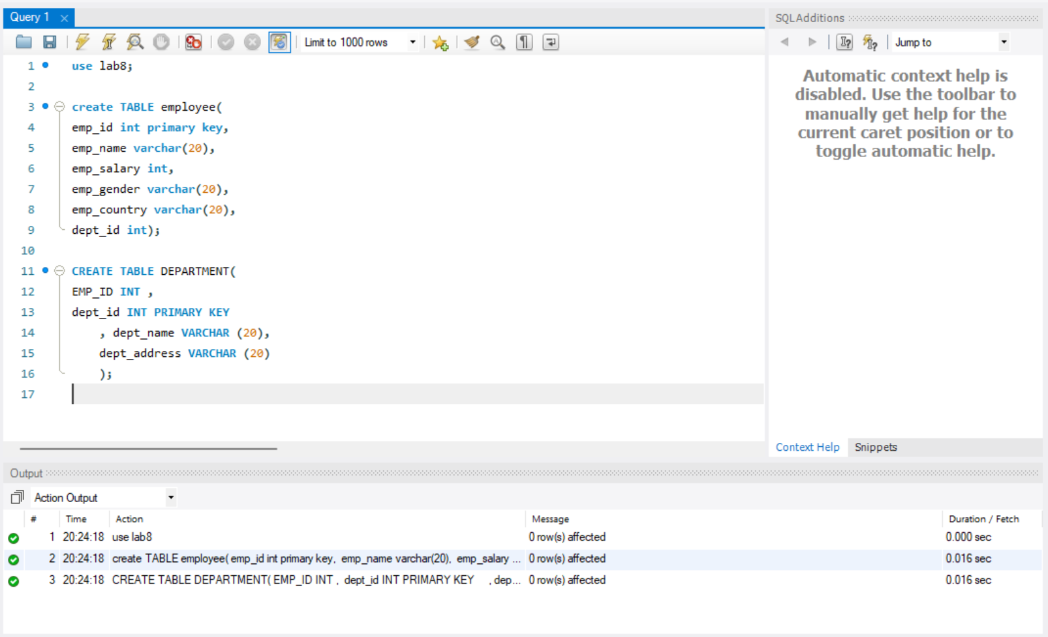

- Create another table department with attributes emp_id, dept_id, dept_name, dept_address.

CREATE TABLE DEPARTMENT(
EMP_ID INT ,
dept_id INT PRIMARY KEY
, dept_name VARCHAR (20),
dept_address VARCHAR (20)
);

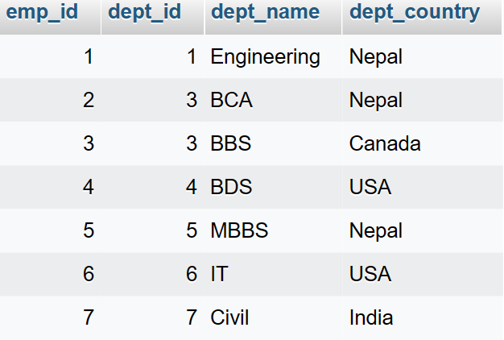

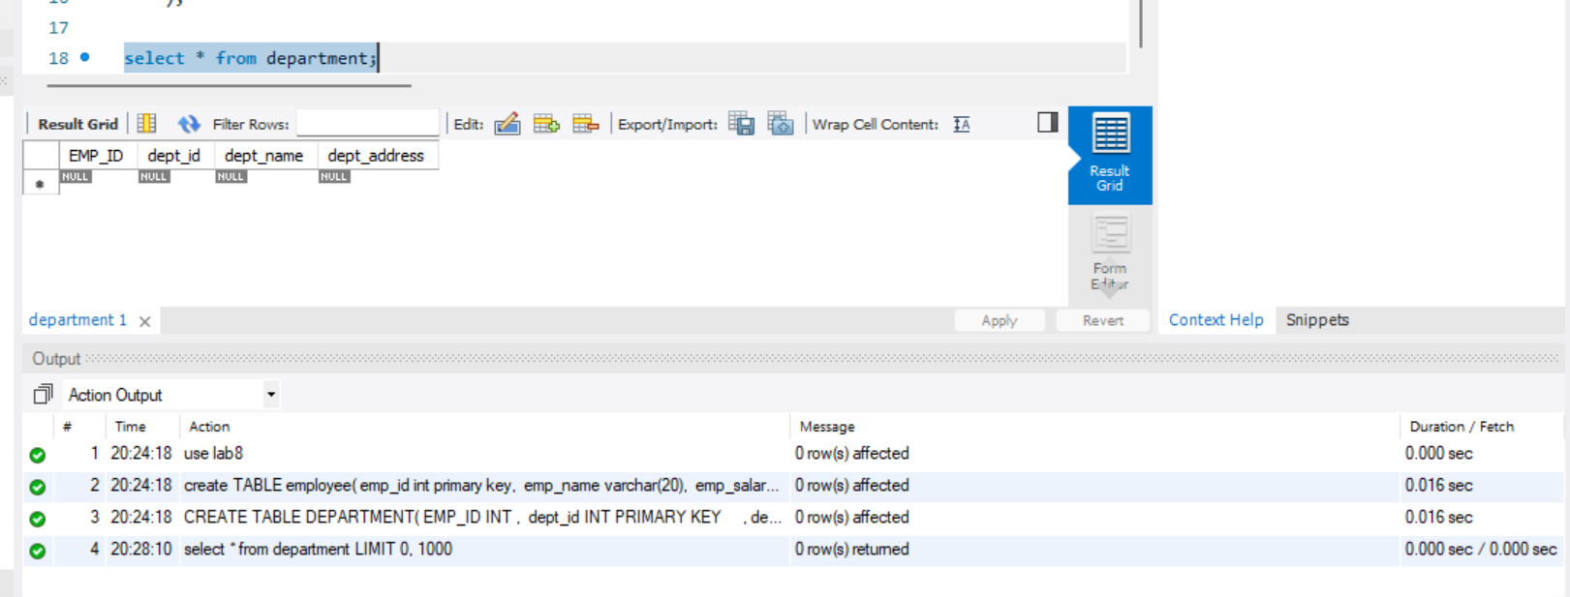

- Insert at least 5 row.

use lab8;
INSERT INTO employee VALUES
(1,'SIMANTA',200000,'MALE','NEPAL',11),
(2,'PRASHANT',500000,'MALE','USA',12),
(3,'SALINA',40000,'FEMALE','NEPAL',13),
(4,'SHASHI',10000,'FEMALE','USA',14),
(5,'PURAN',400000,'MALE','USA',15);

INSERT INTO DEPARTMENT VALUES
(1,11,'ENGINEERING','KTM'),
(2,12,'Management','LA'),
(3,13,'BCA','chitwan'),
(4,14,'civil','UTAH'),
(5,15,'Computer','UTAH');

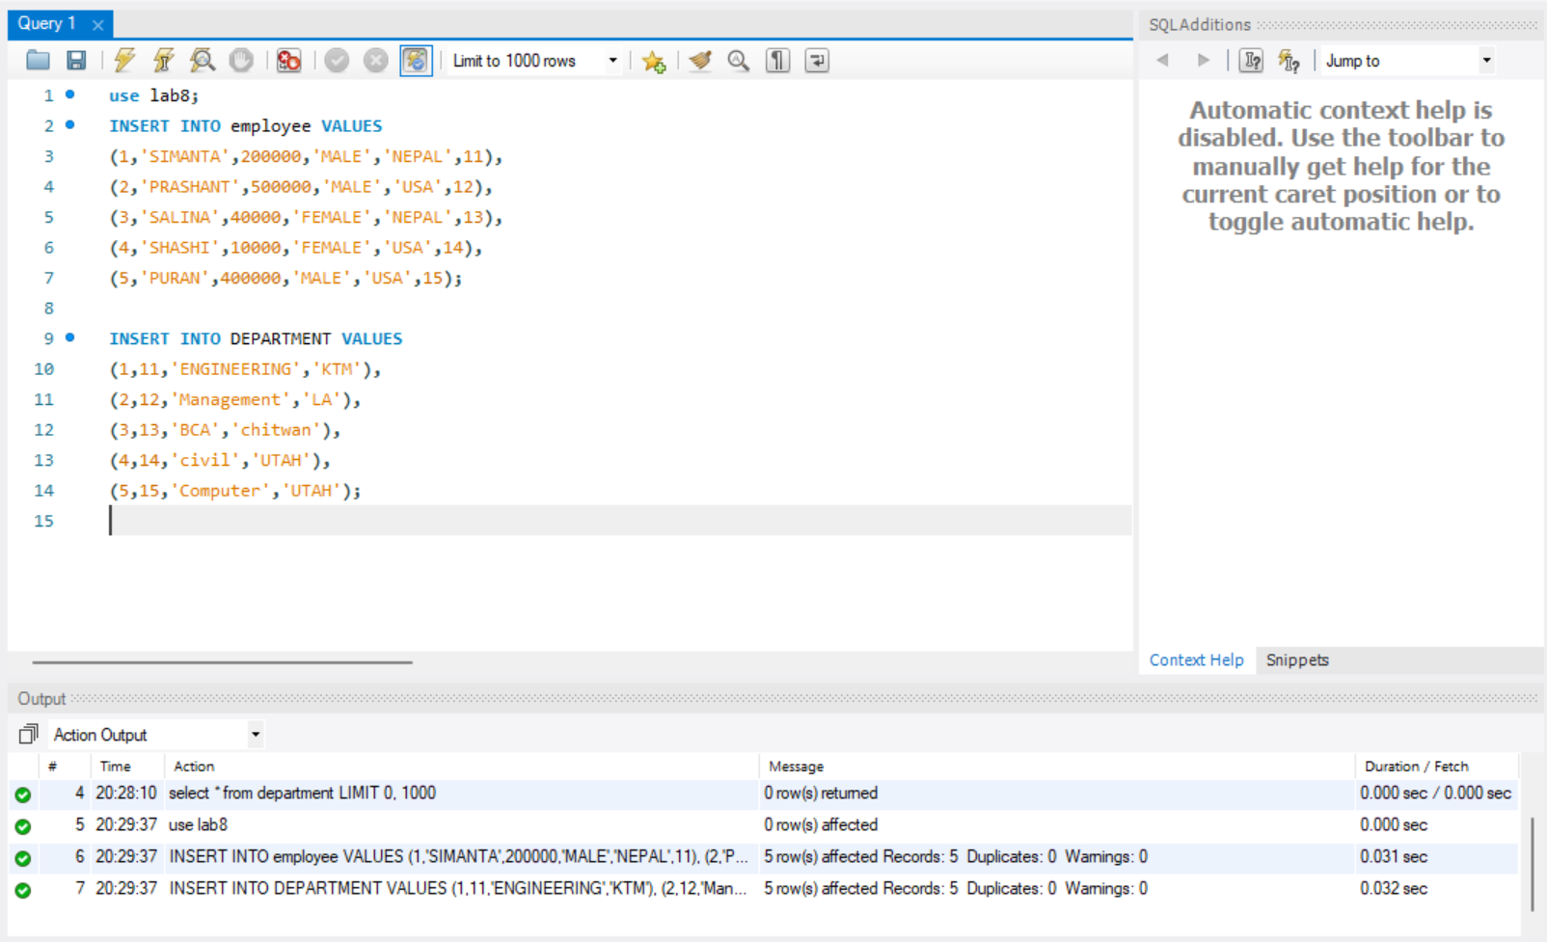

- Display all the information of employee where salary lies between 60000 to 1 lakh and id not lies in 1,2,3,4.

use lab8;
select * from employee WHERE Emp_salary BETWEEN 60000 and 100000 and emp_id not in(1,2,3,4);

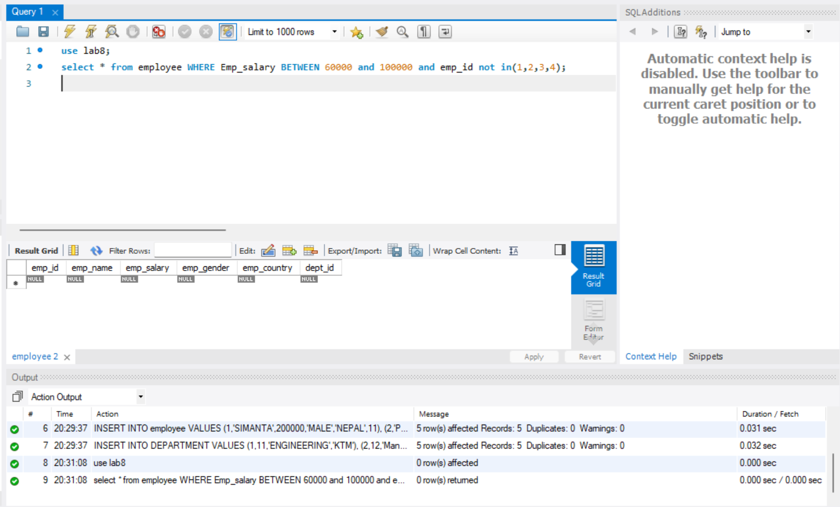

Display all the information of employee where salary lies between 60000 to 1 lakh and id lies in 1,2,3,4.

use lab8;
select * from employee WHERE Emp_salary BETWEEN 60000 and 100000 and emp_id in(1,2,3,4);

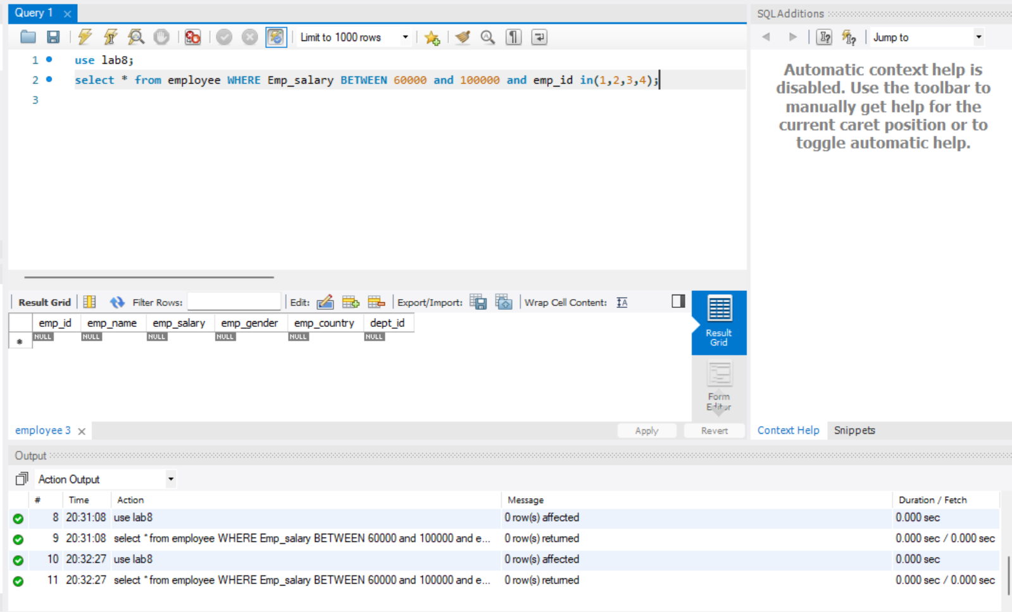

- Display name of an employee as employee of the month whose salary is greater than 90000.

use lab8;
SELECT emp_name as employee_of_the_month FROM `employee` WHERE Emp_salary>90000;

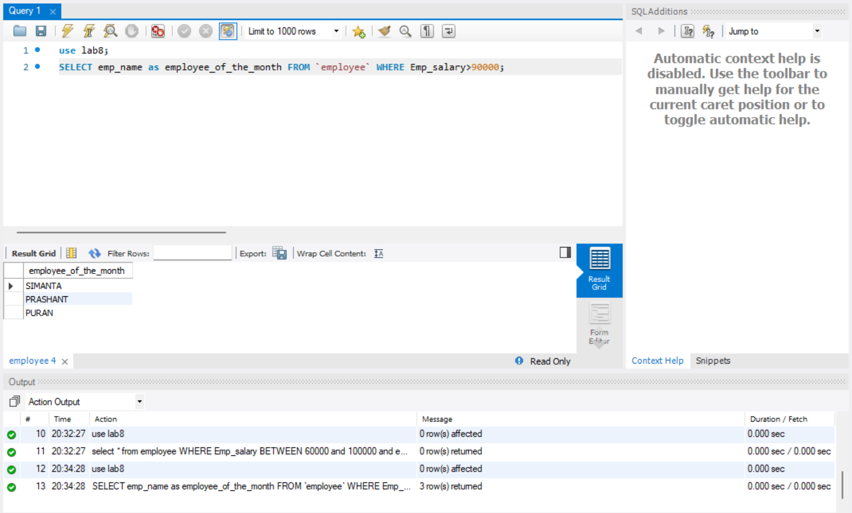

- Group the employee table by salary.

use lab8;
SELECT * FROM employee GROUP by Emp_salary;

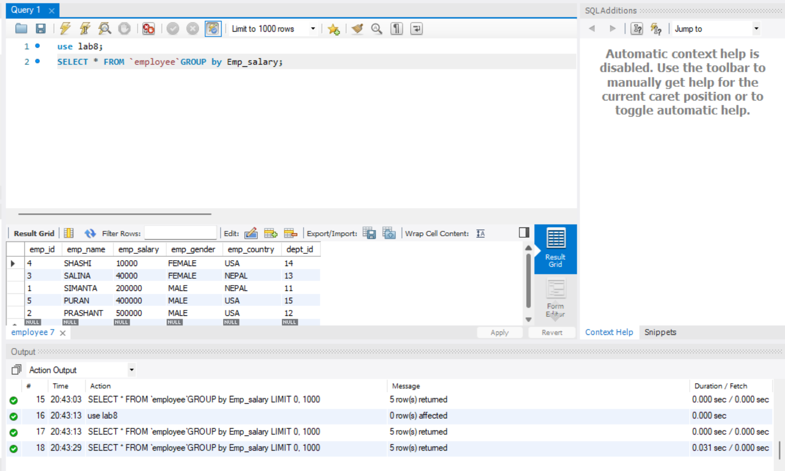

- Group the employee table by name and salary.

use lab8;
SELECT * FROM employee GROUP by emp_name, emp_salary;

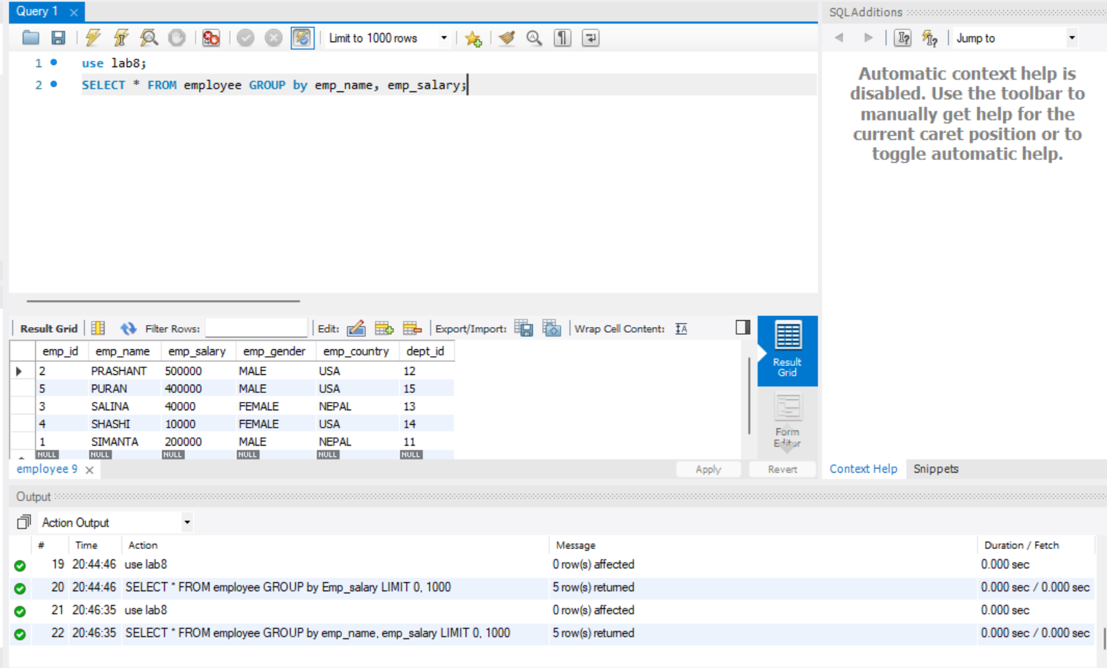

- Group department table by dept_name.

use lab8;
SELECT * FROM department group by dept_name;

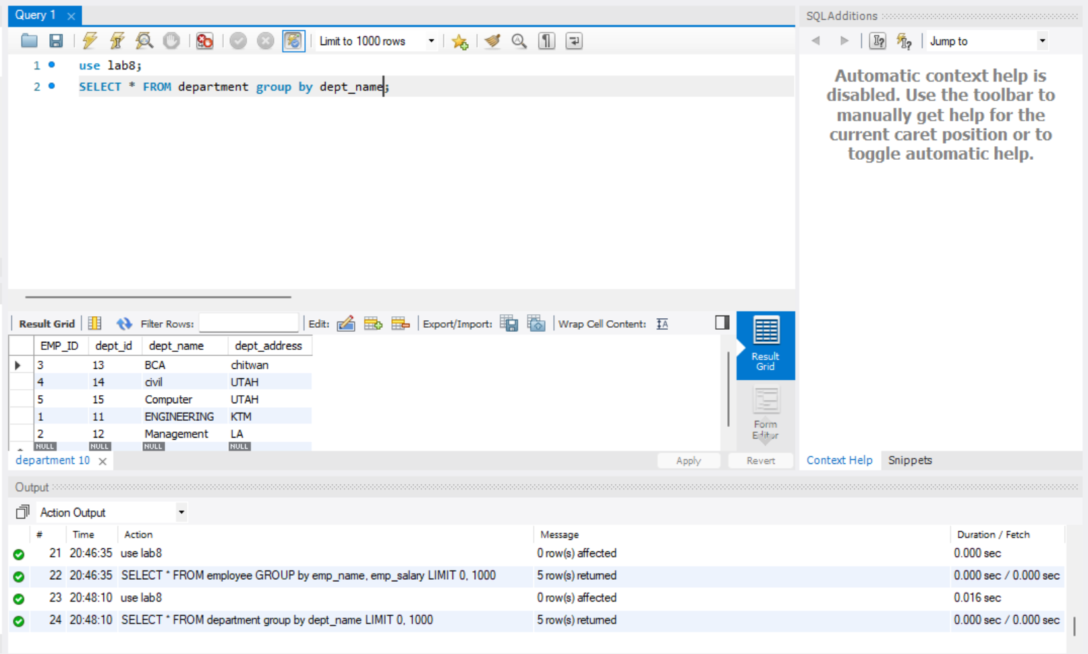

- Group department table by dept_name and dept_id

use lab8;
SELECT * FROM department group by dept_name, dept_id;

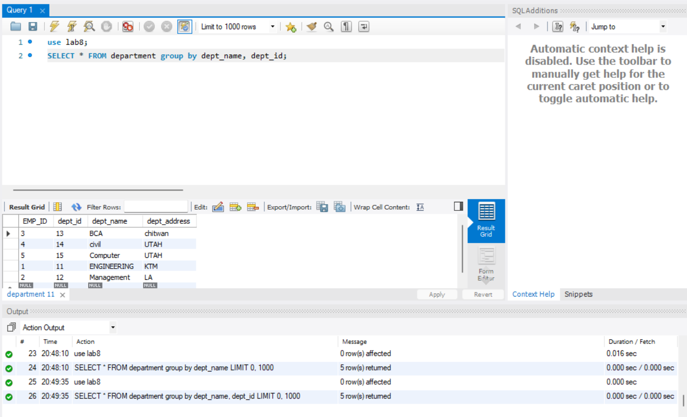

- Select the information of an employee whose country lies in department tabless

use lab8;
SELECT * FROM employee WHERE emp_country IN (SELECT dept_address FROM department);

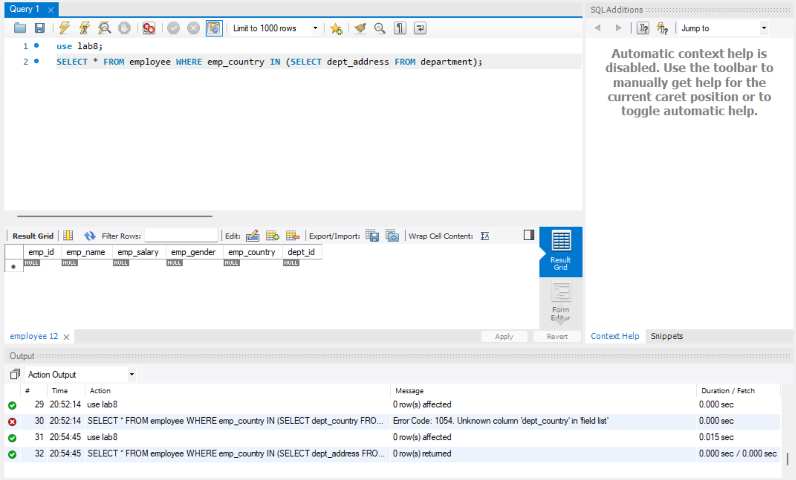

- Group employee table by emp_salary where salary > 15000.

use lab8;
SELECT * FROM employee GROUP by Emp_salary having Emp_salary>15000;

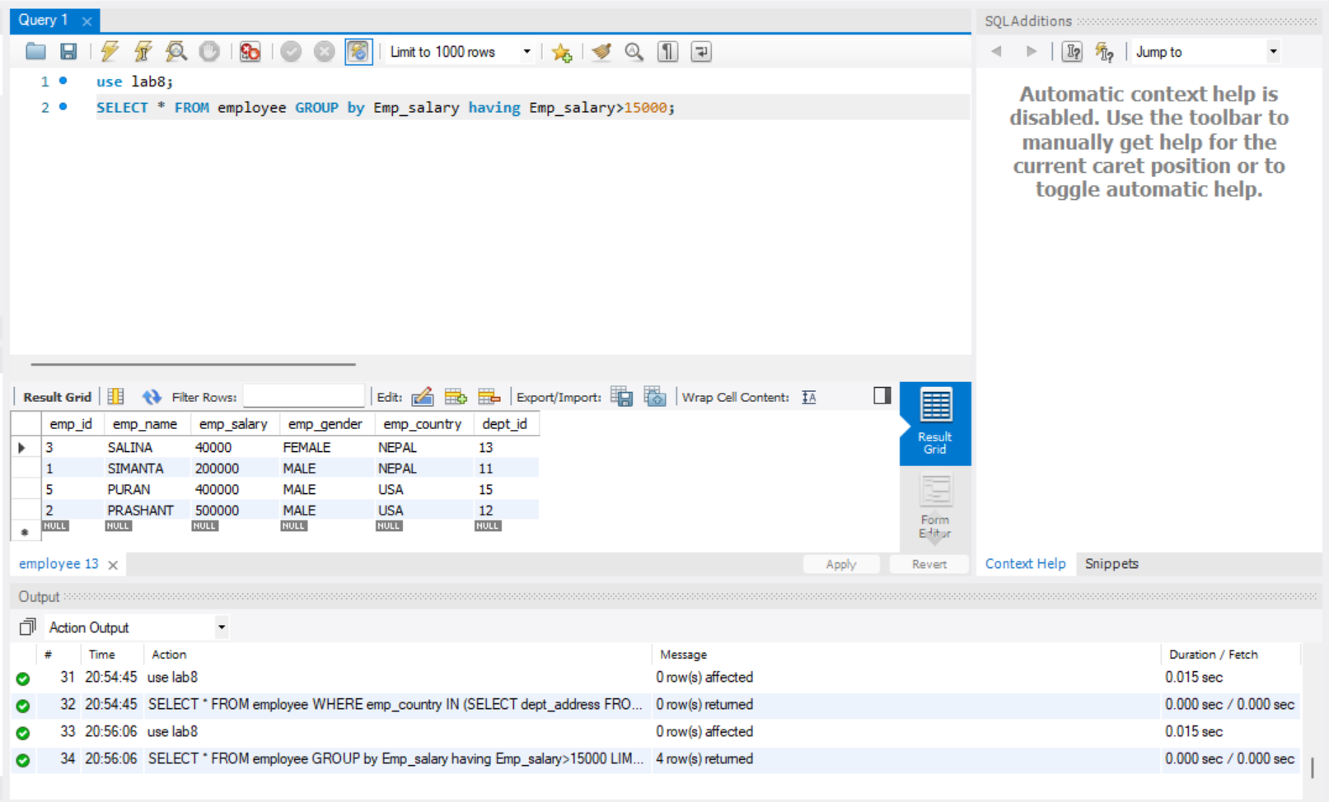

- Display all the dept_name and dept_id having dept_name=engineering.

use lab8;
SELECT dept_name, dept_id FROM department where dept_name='engineering';

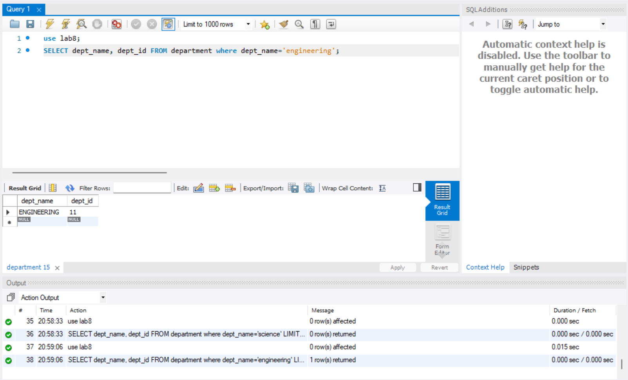

- Order the employee table by name both ascending and descending.

use lab8;
select * from employee order by emp_name asc;
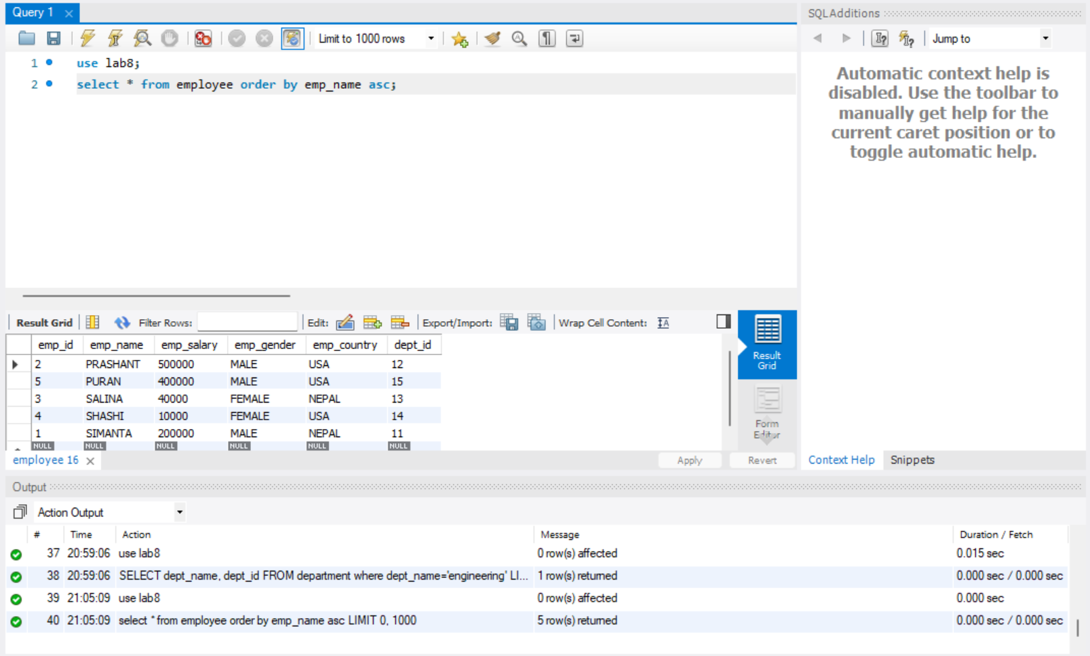

use lab8;
select * from employee order by emp_name desc;
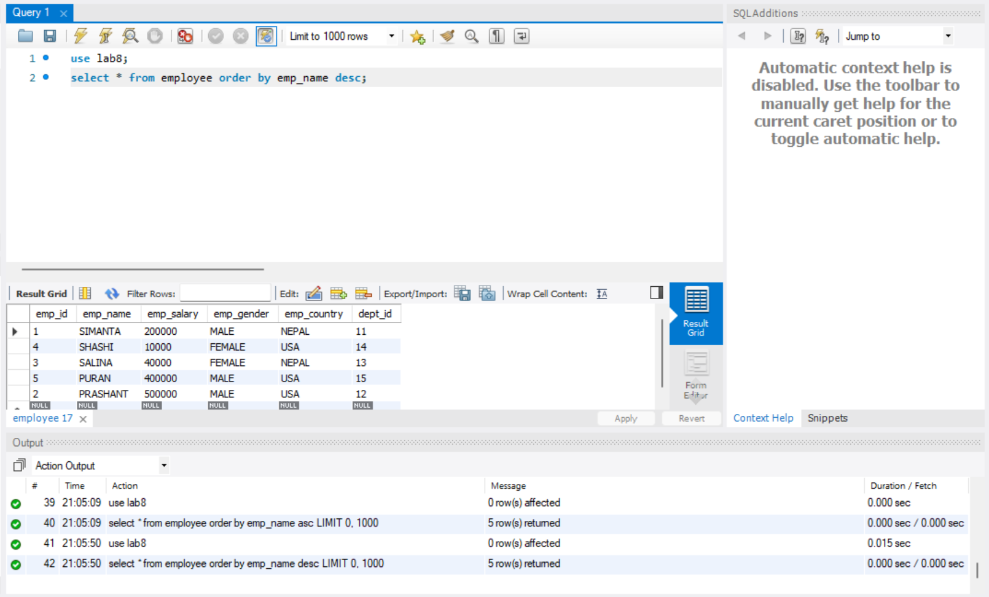
- Order the department table by name both ascending and descending.

use lab8;
select * from department order by dept_name asc;
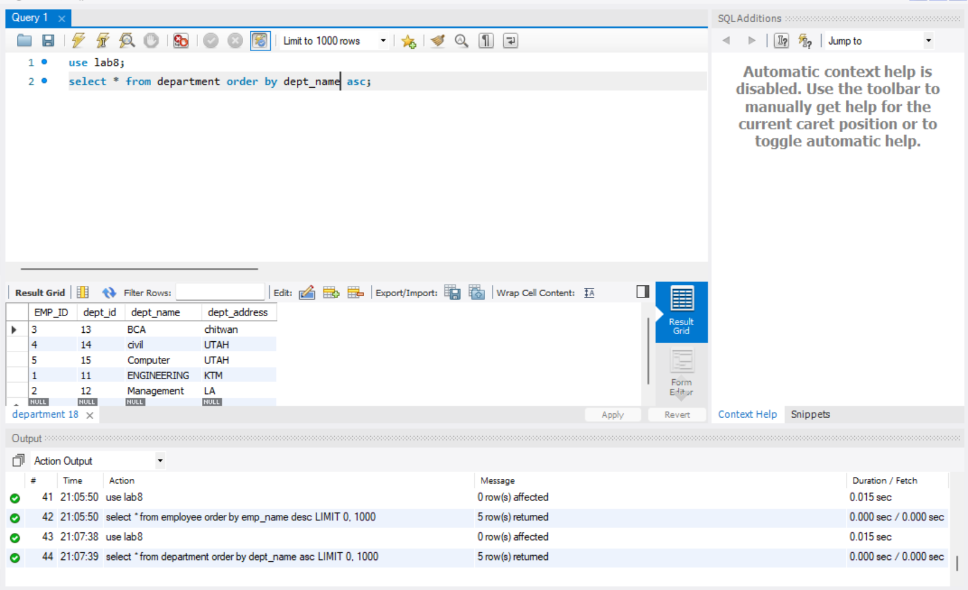

use lab8;
select * from department order by dept_name desc;
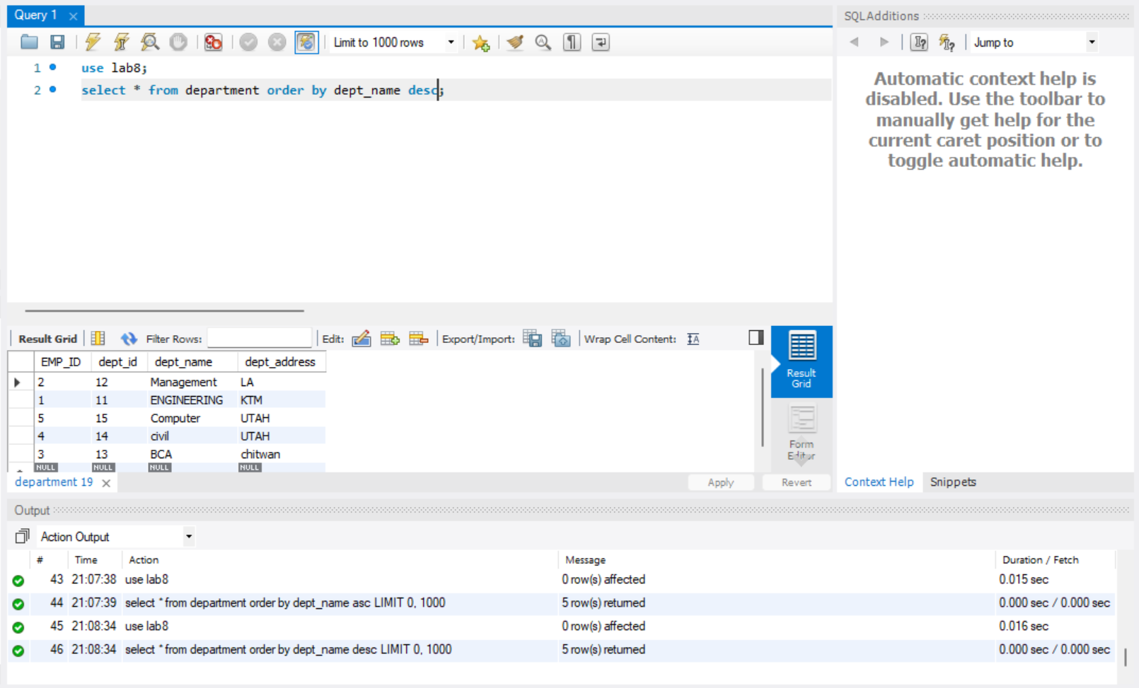

- Find the top 3 employee information who have highest salary.

use lab8;
SELECT * FROM employee ORDER by Emp_salary DESC limit 3;

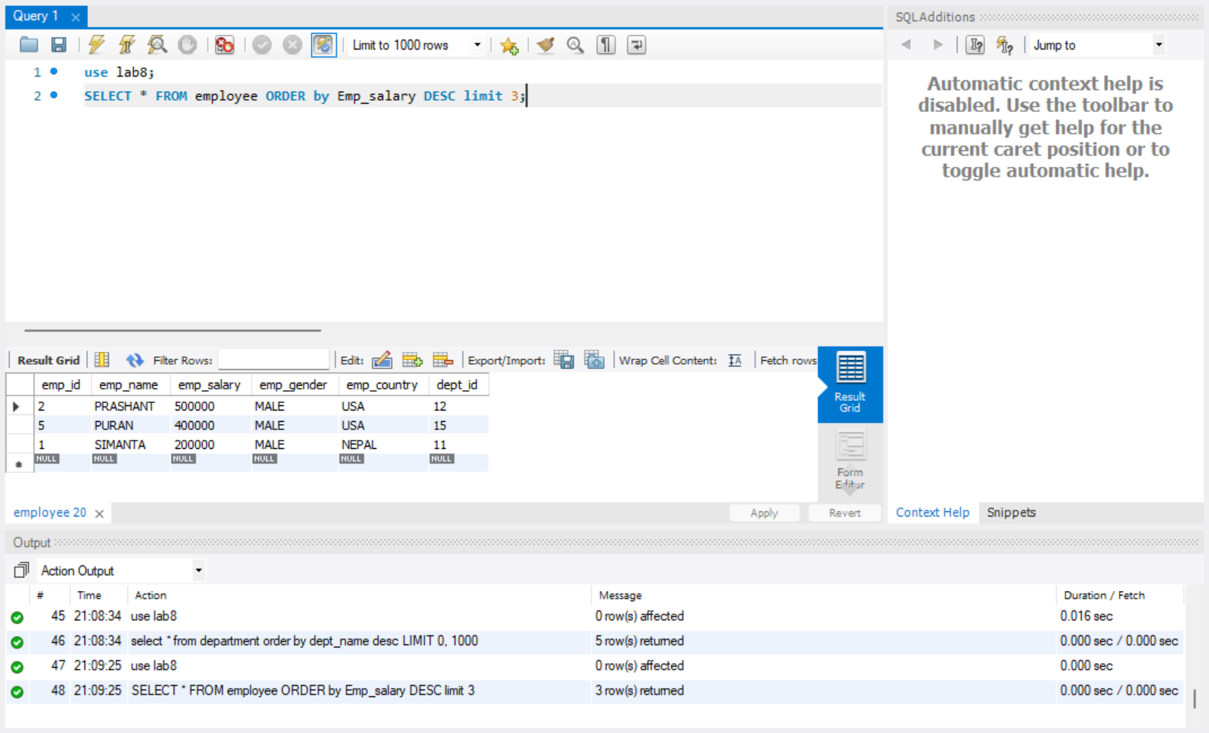

- Alias (As) operator Update the salary of employee by 15% and name them as updated salary.

use lab8;
select emp_salary*1.15 as updated_salary from employee;

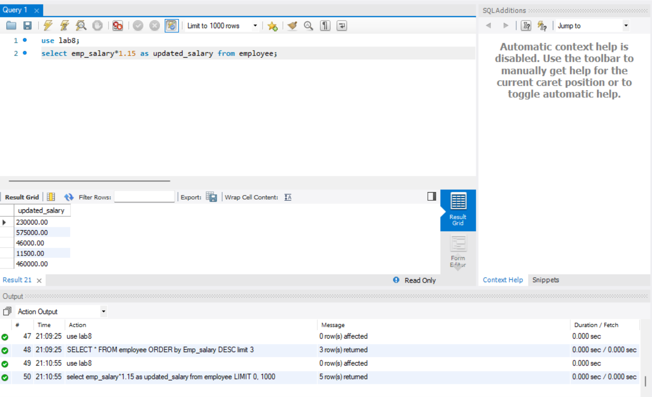

- Select the employee name As name_of_employee.

use lab8;
select emp_name as name_of_employee from employee;

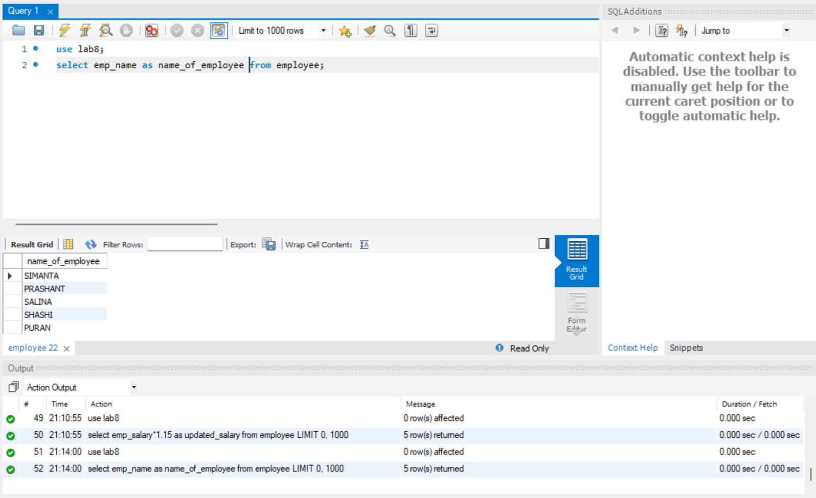

- Select the employee salary As salary_of_employee.

use lab8;
select emp_salary as salary_of_employee from employee;

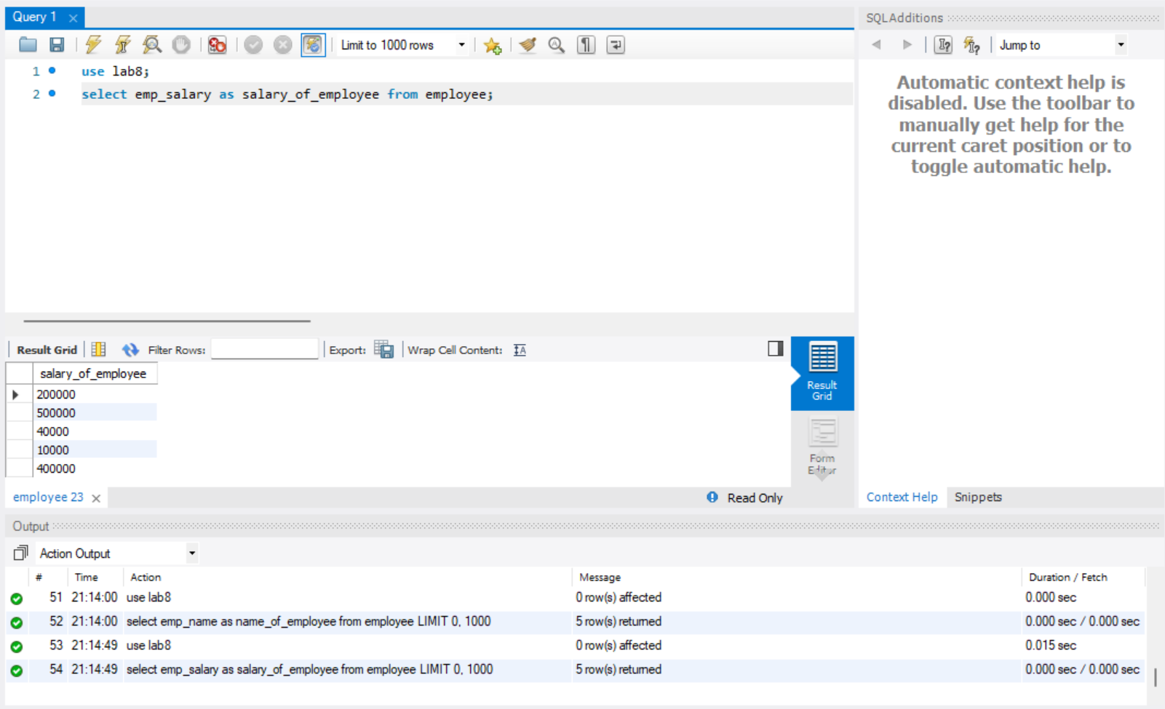

- Select the employee name and employee gender As name and gender.

use lab8;
select emp_name as Name, emp_gender as Gender from employee;

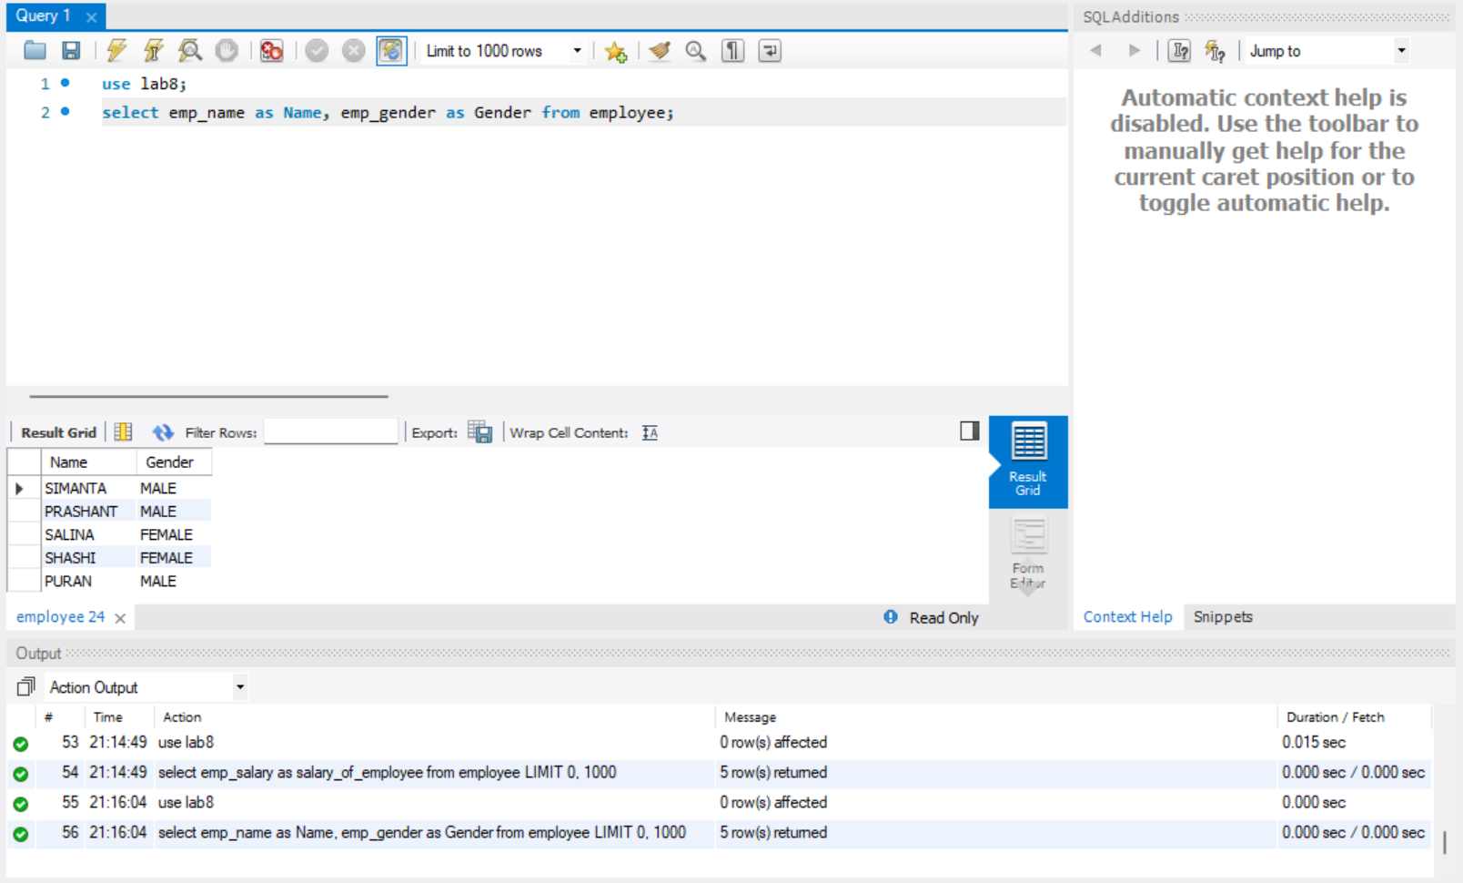

Nested query related question(in,not in,any,exist)

- Select the info of employee from country ‘Nepal’ , ‘England’ , ‘India’.

use lab8;
select * from employee where emp_country in ('nepal','india','japan');

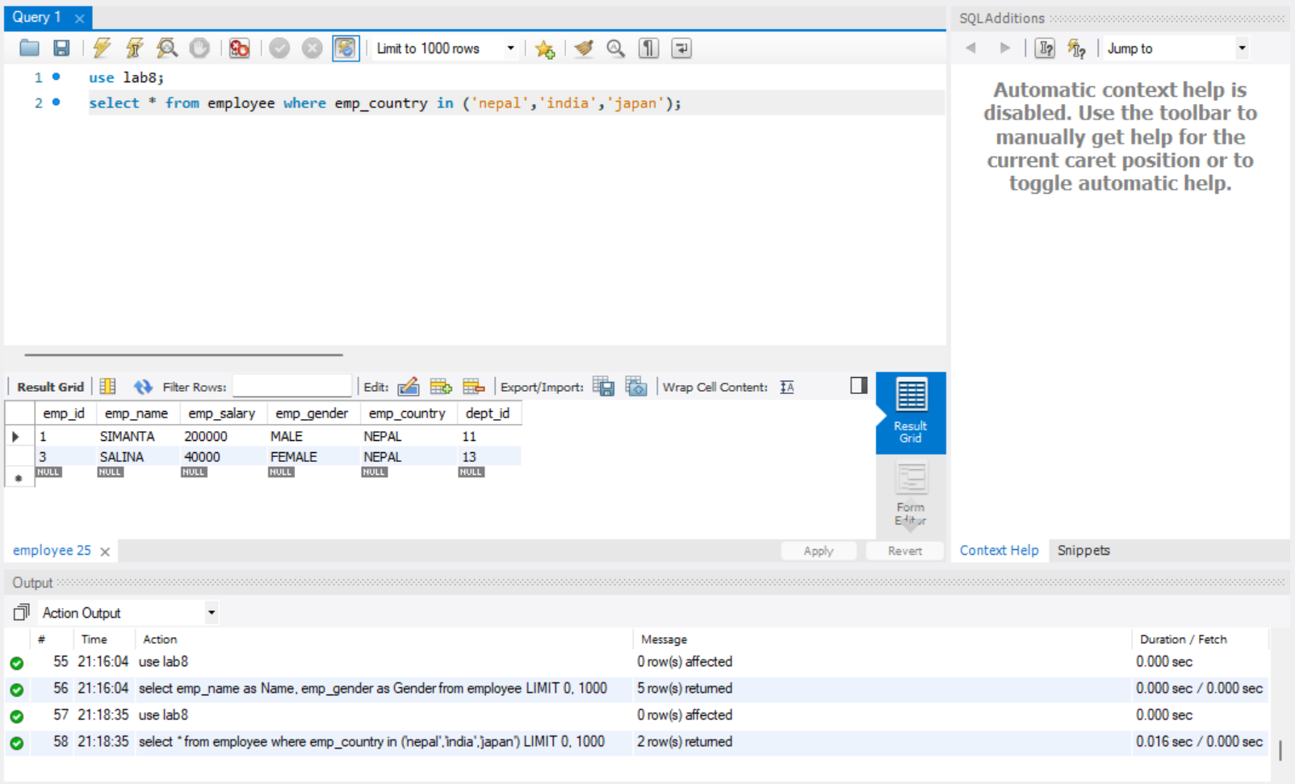

- Select the info of employee not from country England, India.

use lab8;
select * from employee where emp_country not in ('england','india');

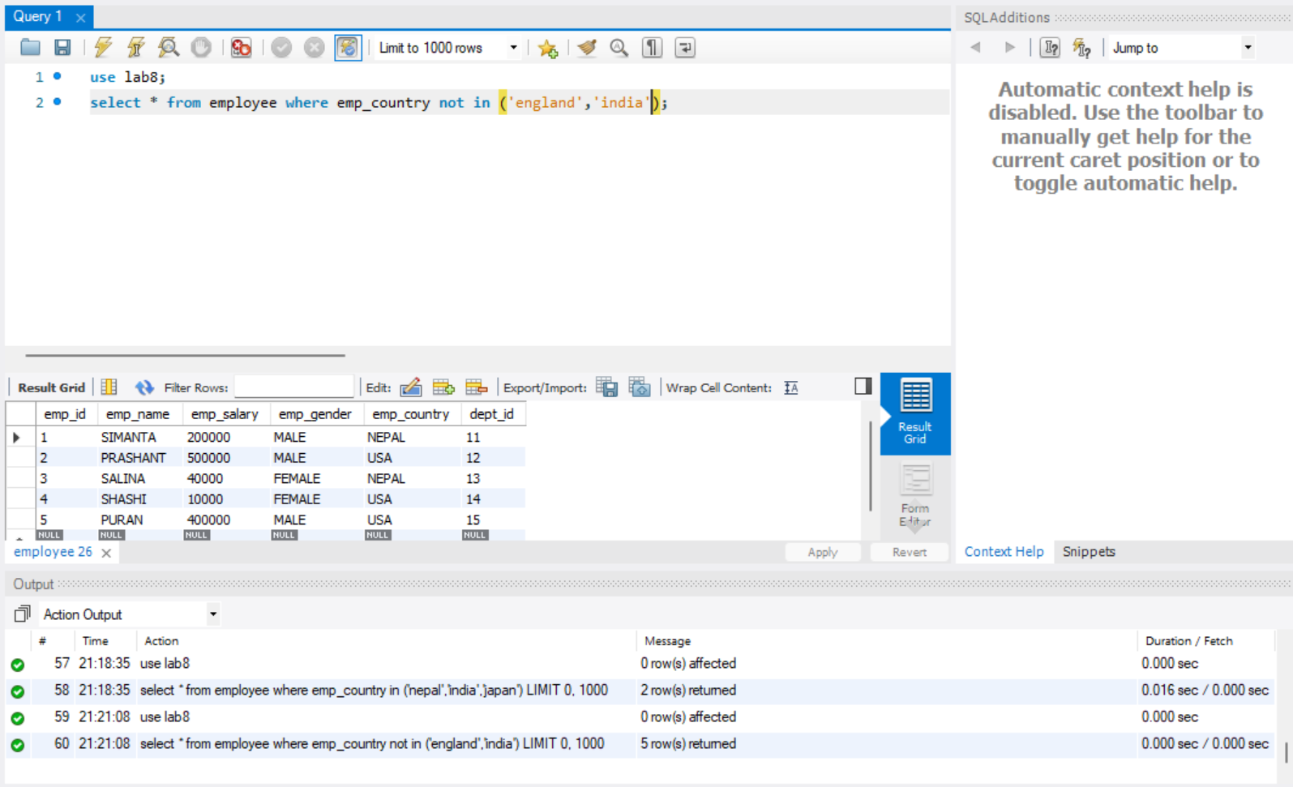

- Select the info of department from address Nepal, England, India.

use lab8;
select * from department where dept_address in ('nepal','england','india');

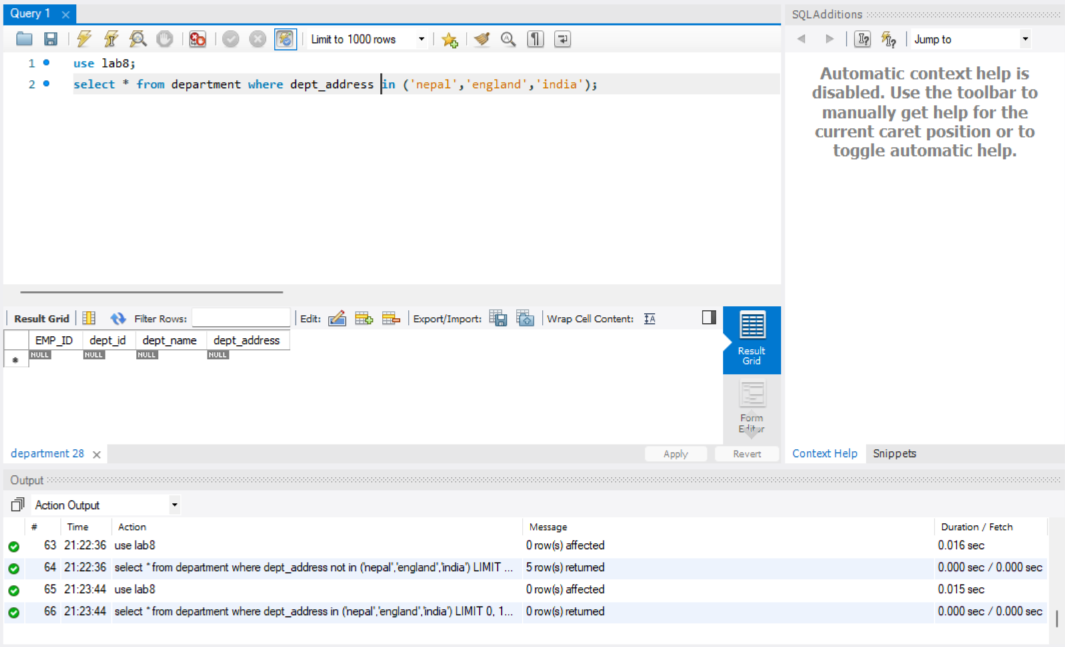

- Select the info of department not from address England, India.

use lab8;
select * from department where dept_address not in ('england','india');

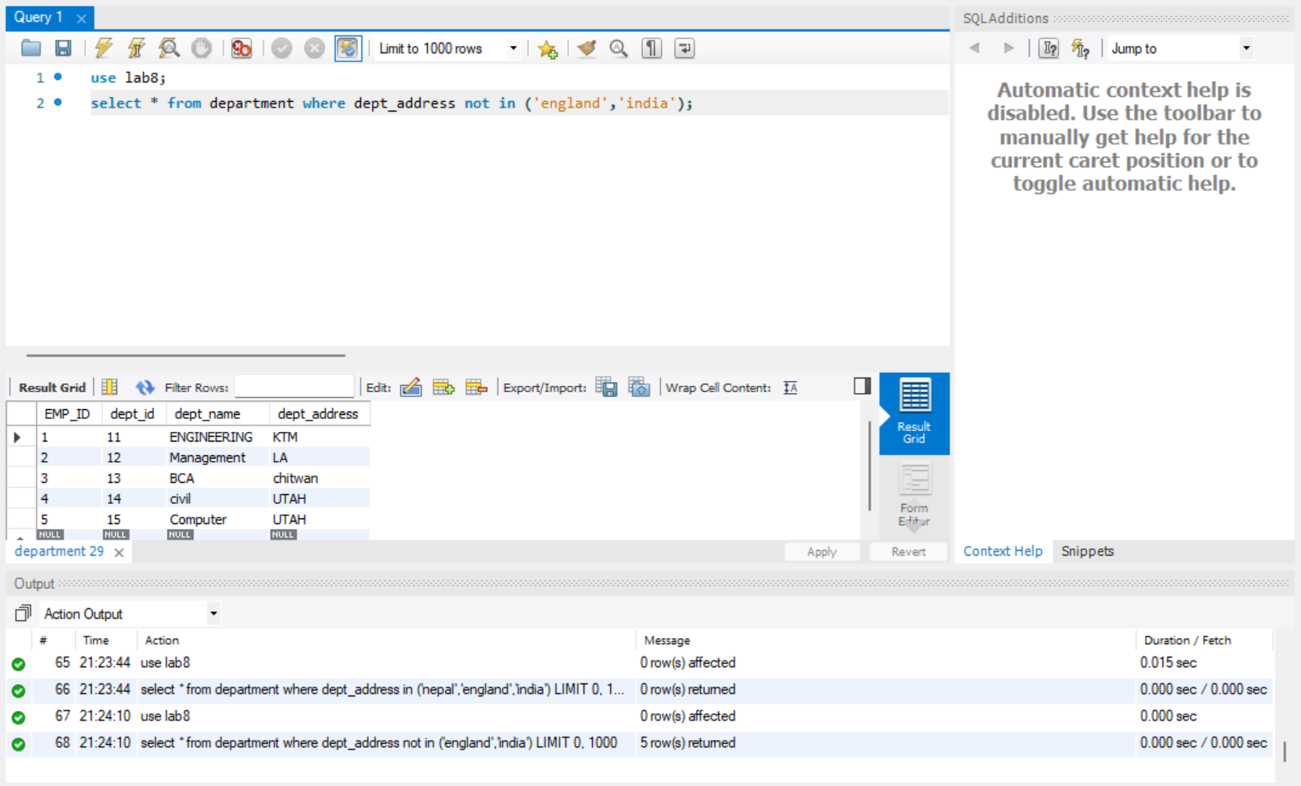

- Select the information of employee whose name is simanta gender is male and country from Nepal ,india,usa.

use lab8;
SELECT * FROM `employee` WHERE emp_name='simanta' and emp_gender='male' and emp_country in ('Nepal','india','usa');

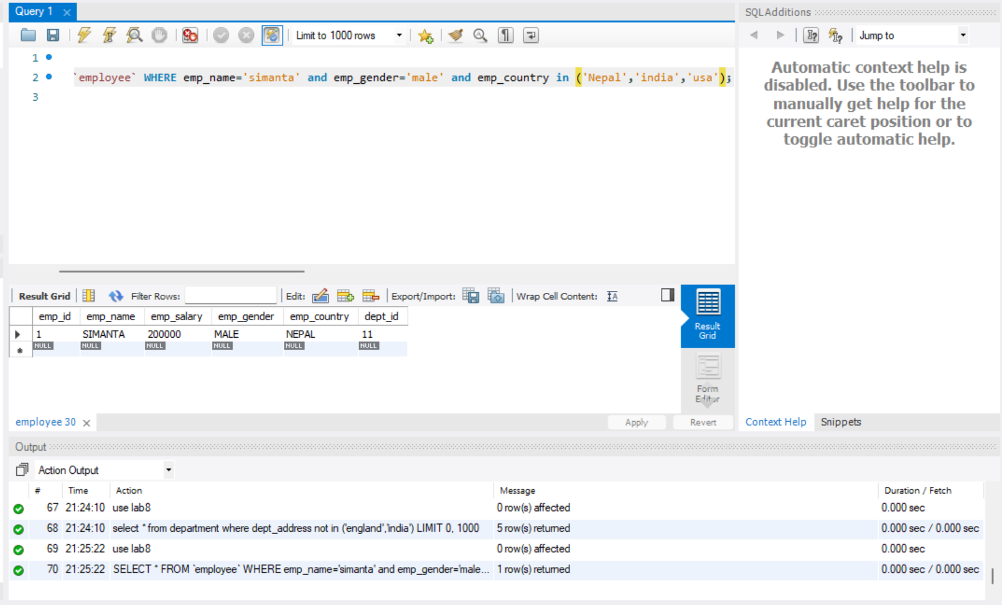

- Select the employee salary where emp_salary belong to emp_id 2.

use lab8;
SELECT emp_salary from employee where emp_id = 2;

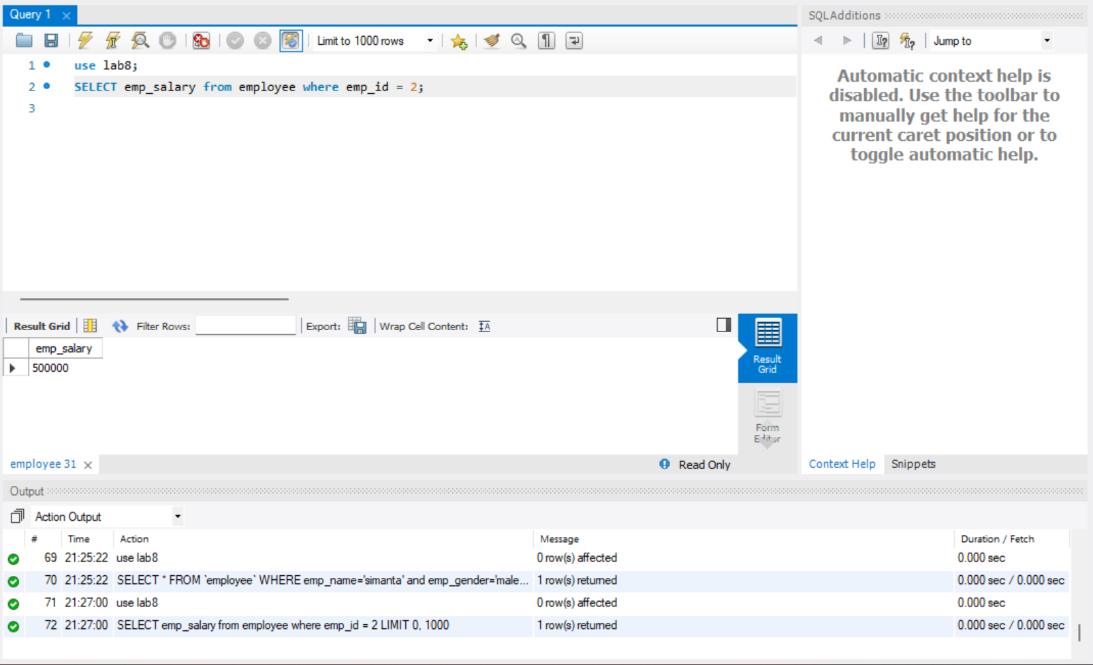

- Select the employee salary whose dept_name is “engineering”.

use lab8;
select emp_salary from employee where dept_id in (select dept_id from department where dept_name ='Engineering');

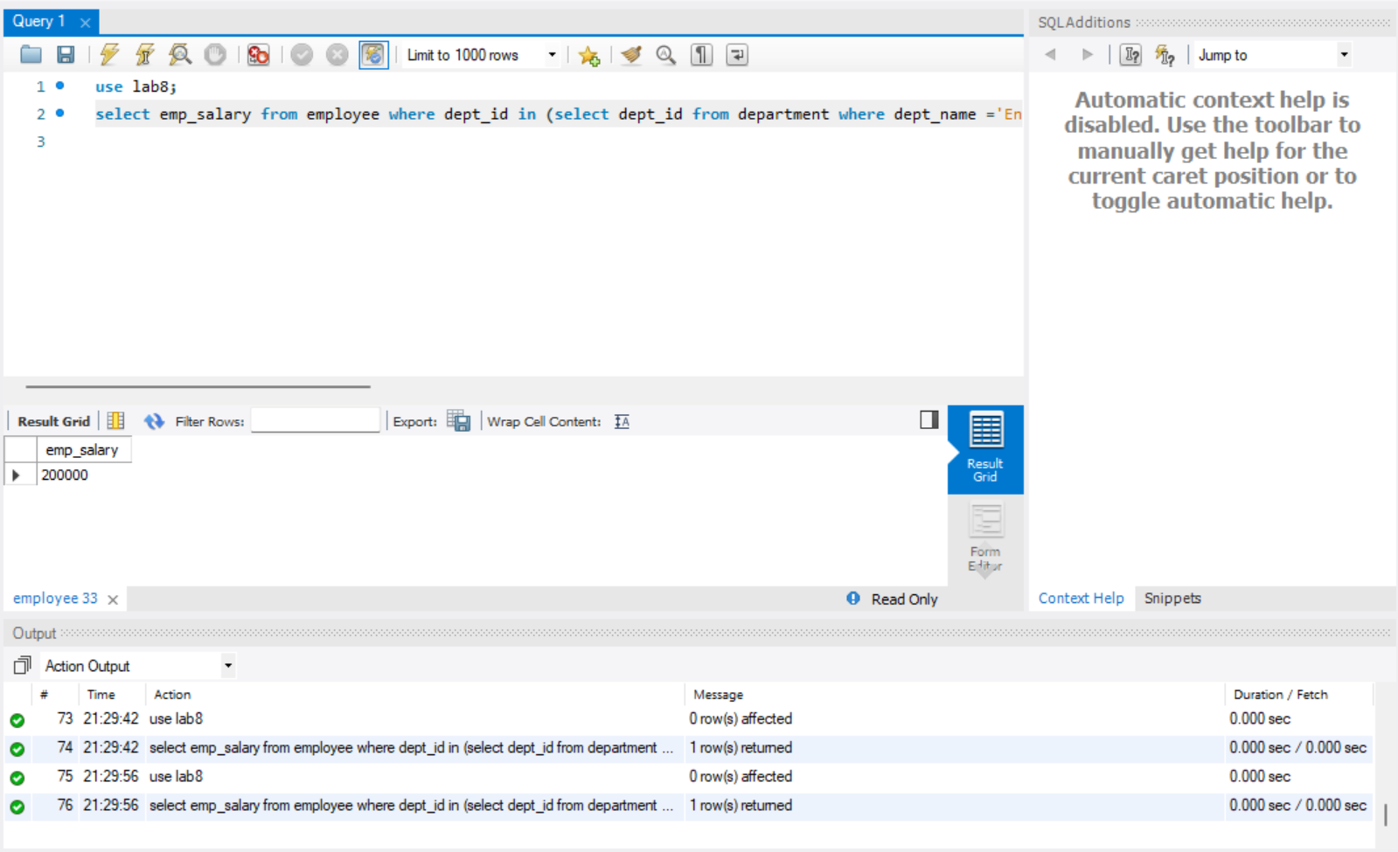

- Select the employee salary whose dept_name is not “engineering”.

use lab8;
select emp_salary from employee where dept_id not in (select dept_id from department where dept_name ='Engineering');

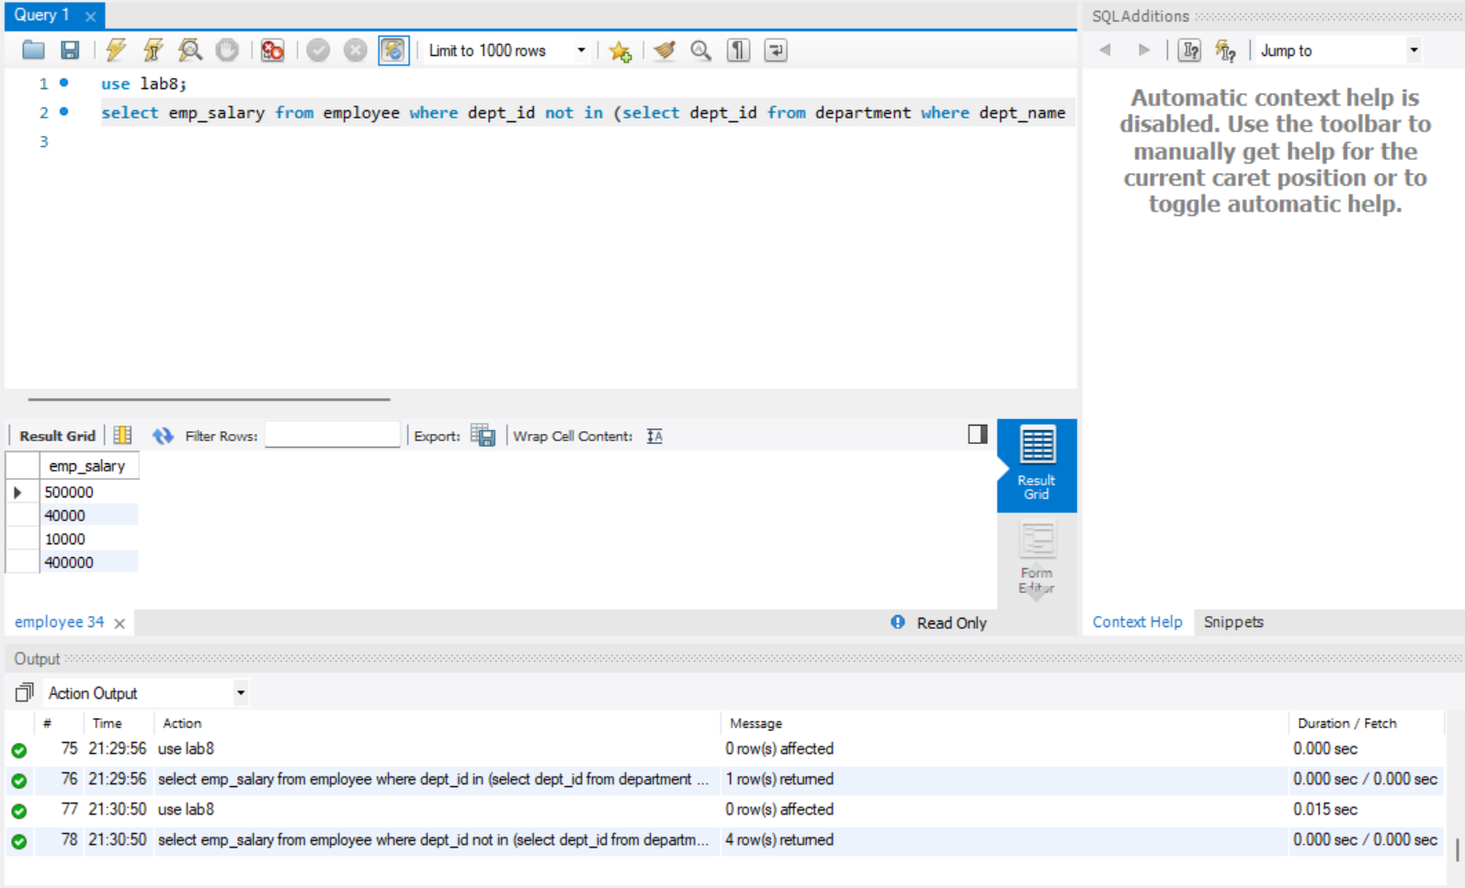

- Select name of the employee for all whose dept is engineering.

use lab8;
select emp_name from employee where dept_id in (select dept_id from department where dept_name = 'Engineering')

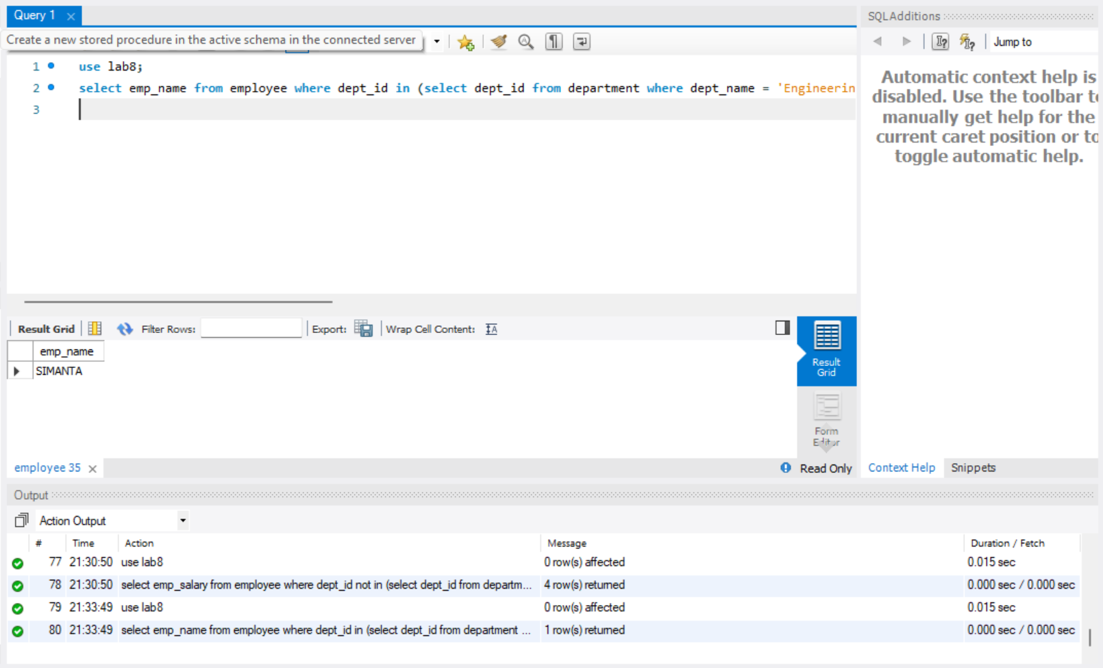

- Select department name whose salary is >18000.

use lab8;
select dept_name from department where dept_id in (select dept_Id from employee where emp_salary>18000);

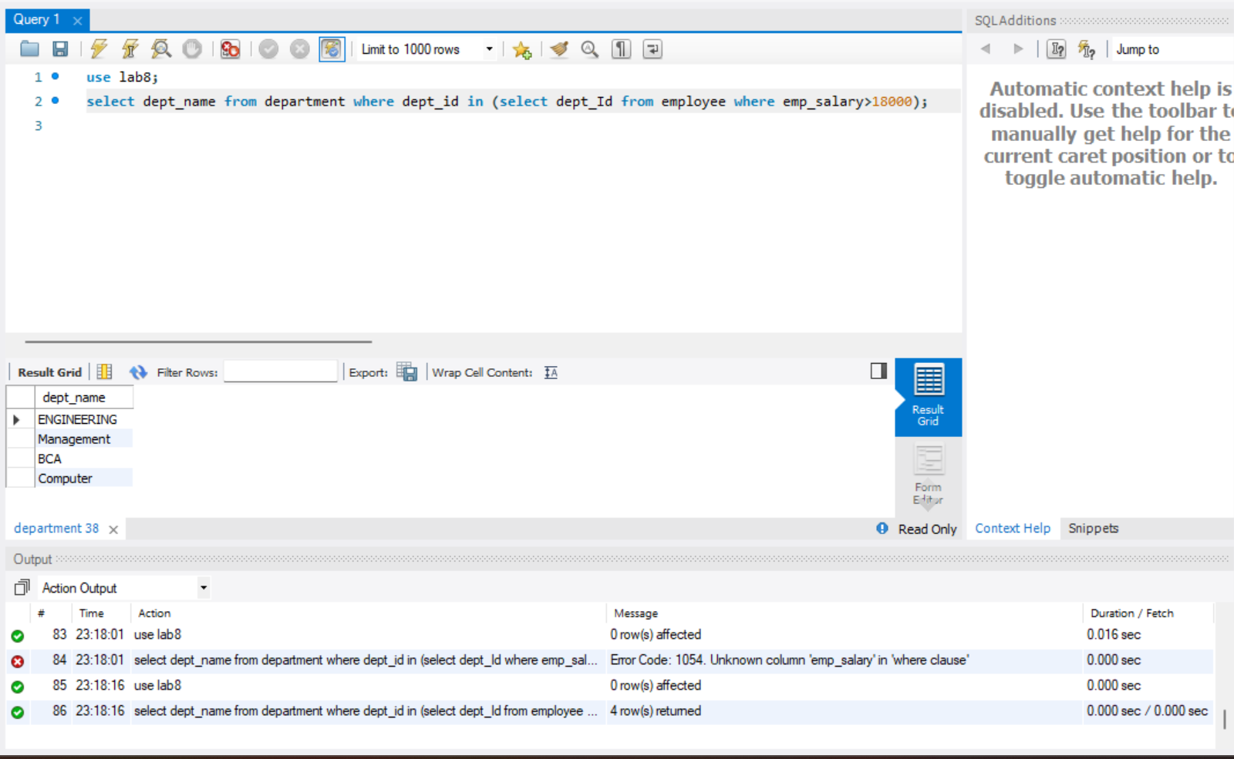

- Select dept_address and dept_name whose name is “salina”.

use lab8;
select dept_name, dept_address from department where dept_id in (select dept_Id from employee where emp_name='salina');

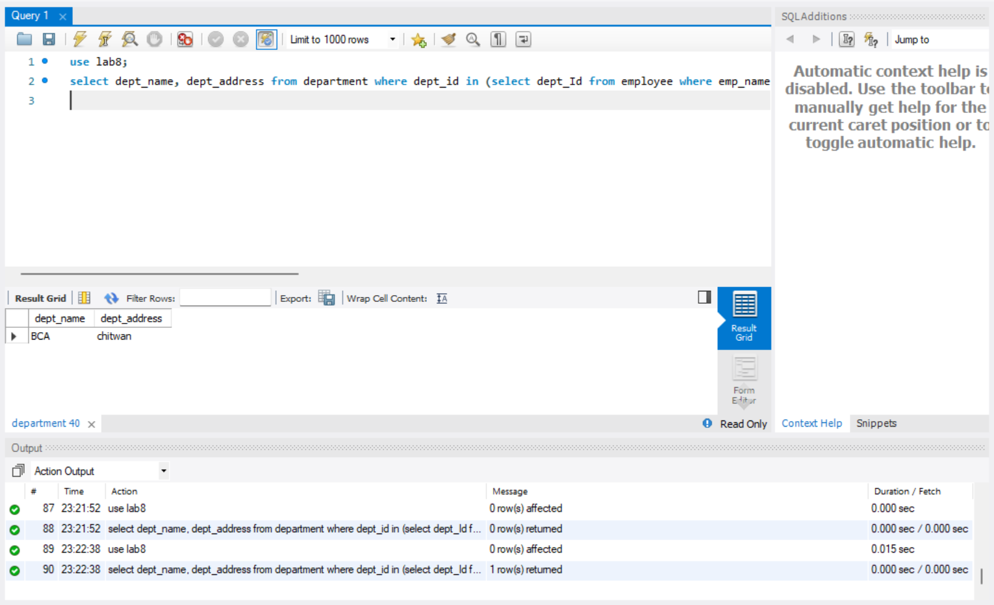

- Select dept_address and dept_name who is from USA.

use lab8;
select dept_name, dept_address from department where dept_id in (select dept_Id from employee where emp_country='USA');

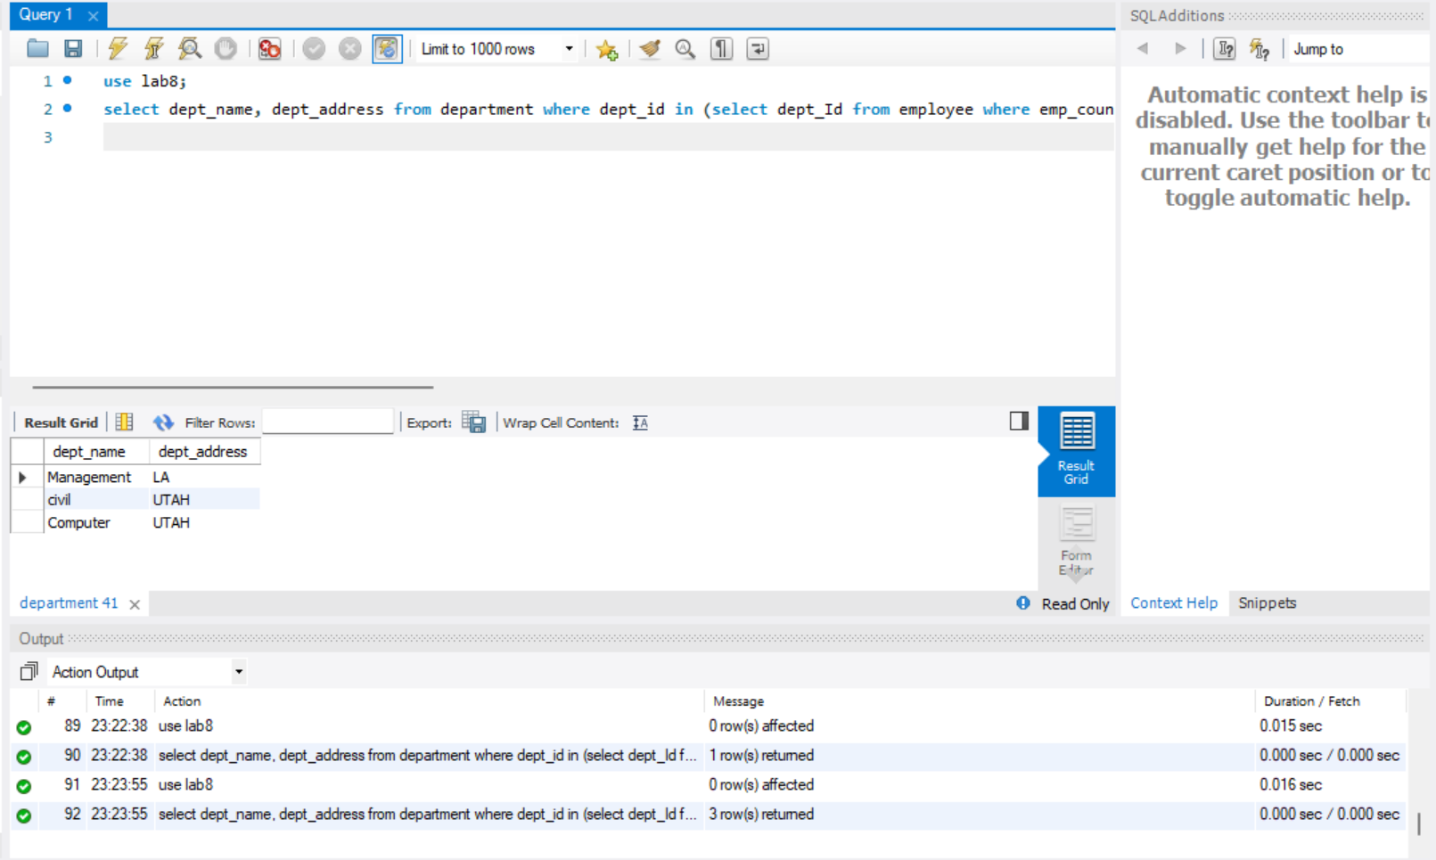

- Use all the employee address that are in department table using ‘All’ operator.

use lab8;
SELECT * from employee
WHERE emp_country = ALL (SELECT dept_address FROM department);

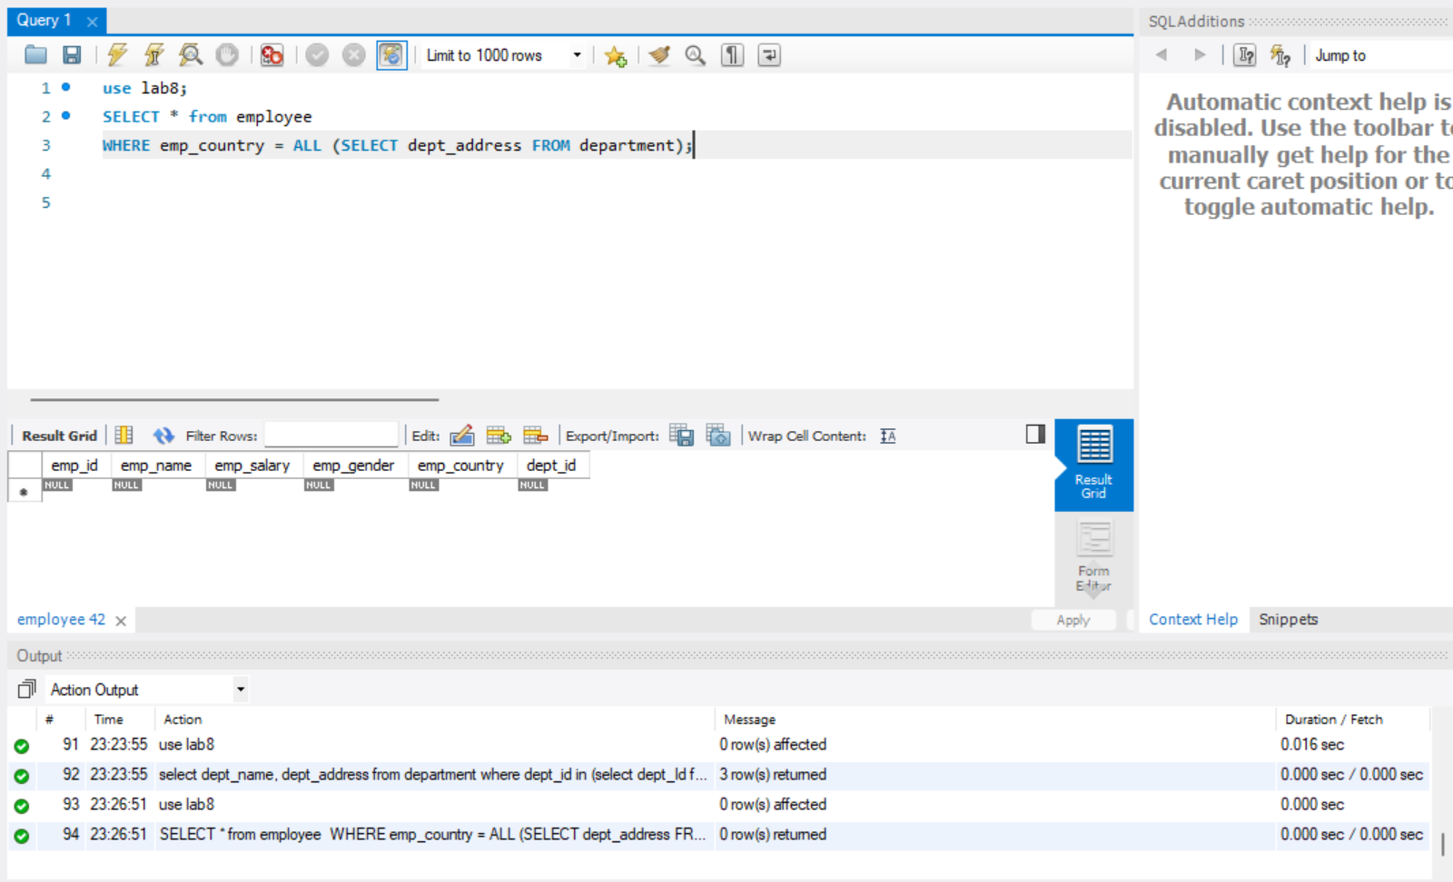

- Create your own que that use ‘Any’ operator.

Find the employees whose emp_country matches any of the dept_address in the department table.

use lab8;
SELECT emp_name, emp_country
FROM employee
WHERE emp_country = ANY (SELECT dept_address FROM department);

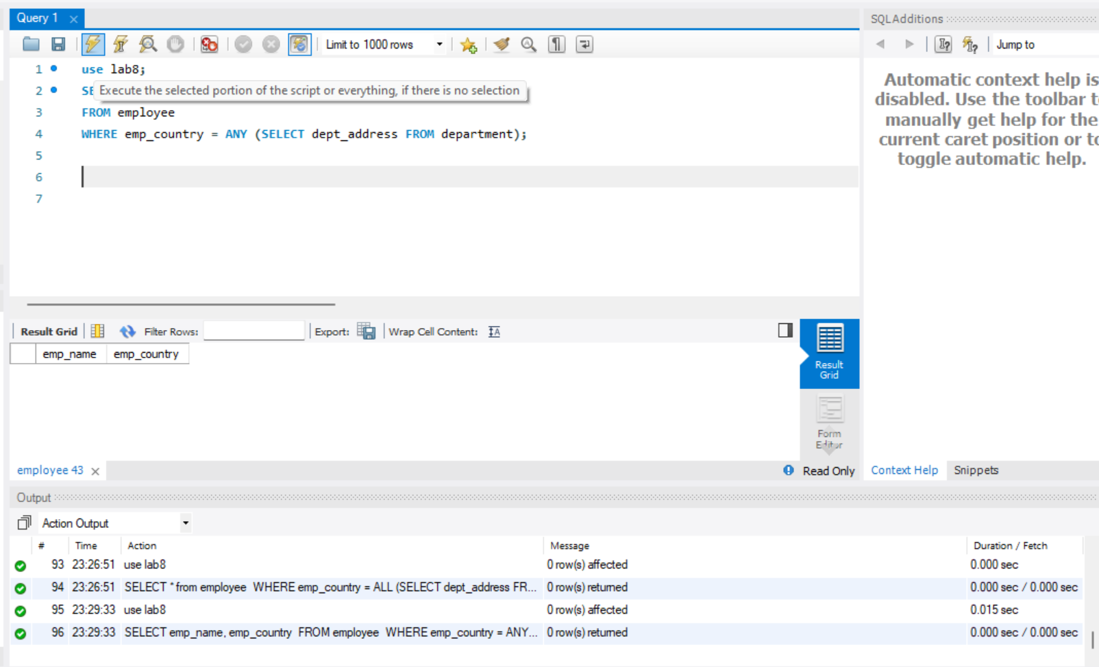

- Using case clause display employee name and salary and given a text message whether the salary is greater or less than 5000 or equal to 5000.

use lab8;
select emp_name, emp_salary,
case
when emp_salary>5000 then 'Salary is greater than 5k'
when emp_salary=5000 then 'Salary is equal to 5k'
else 'Salary is less than 5k'
end as Remarks
from employee;

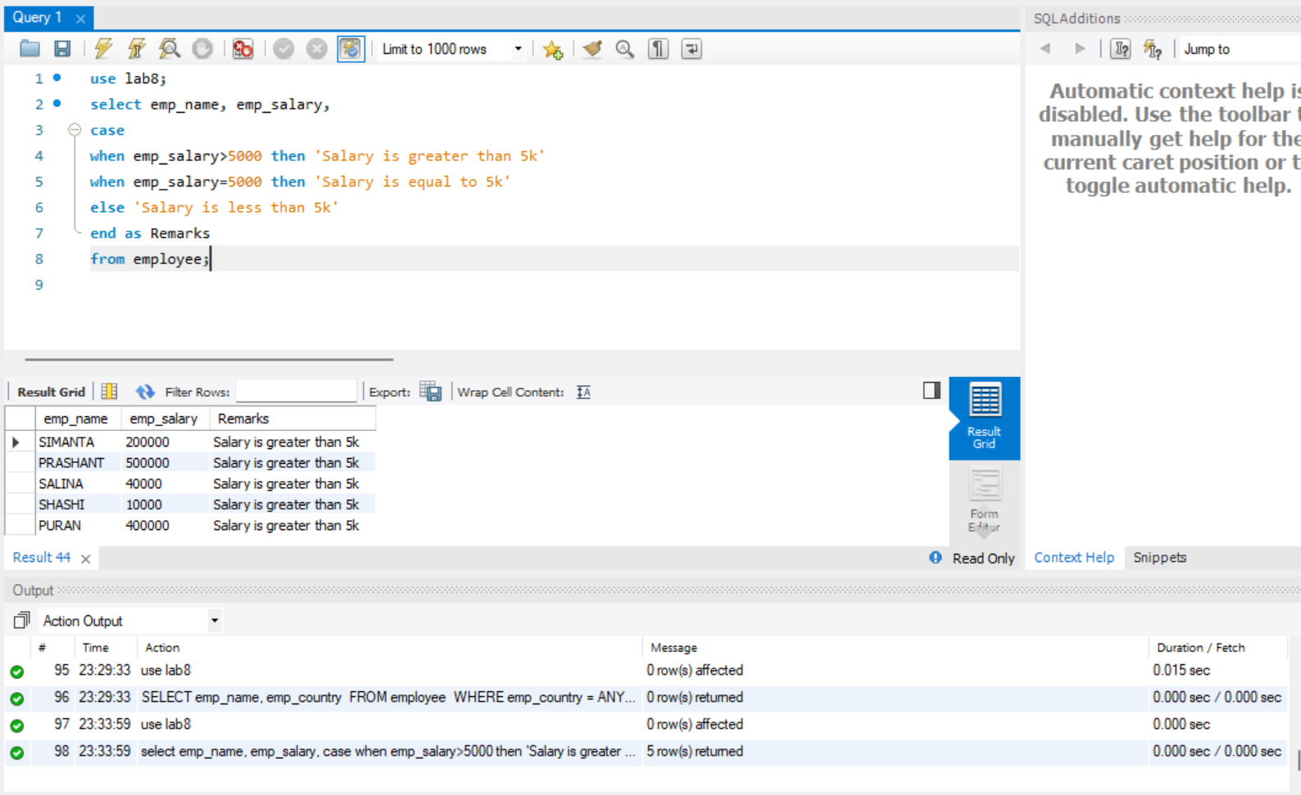

- Perform the union operation between emp country and department address.

use lab8;
SELECT emp_country AS location
FROM employee
UNION
SELECT dept_address AS location
FROM department;

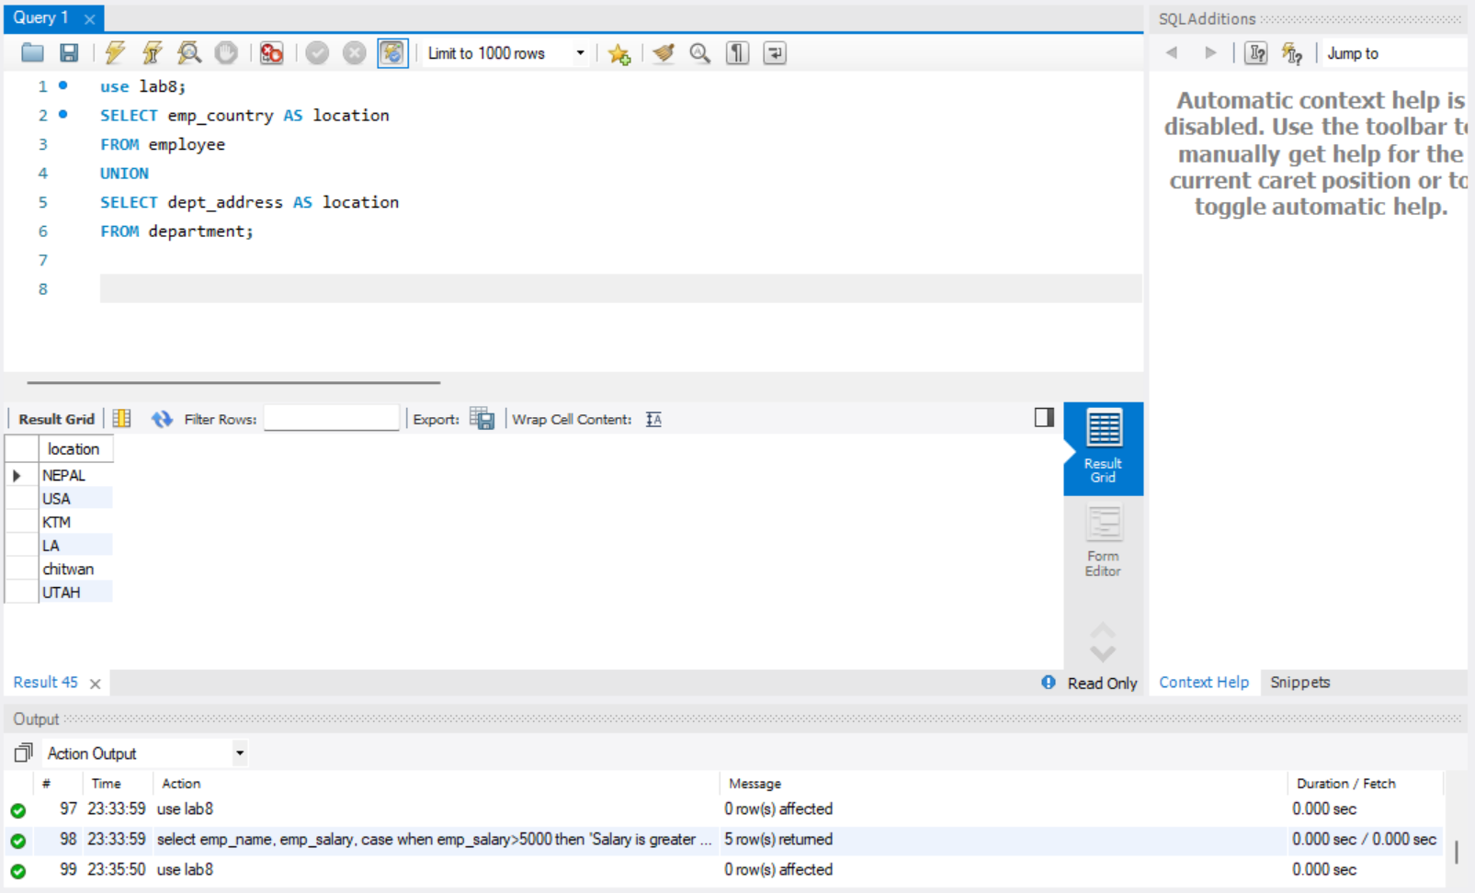

CONCLUSION:
In this practical, we explored various SQL clauses and commands to retrieve, filter, group, and manipulate data effectively. By working with clauses like SELECT, FROM, WHERE, GROUP BY, HAVING, and ORDER BY, we learned to query data systematically and present it in a structured manner. The use of BETWEEN and NOT BETWEEN allowed for range-based filtering, while alias operations simplified column and table names for better readability.
Additionally, nested queries using operators such as IN, NOT IN, ALL, ANY, and EXISTS provided powerful tools to handle complex data retrieval scenarios. The implementation of CASE statements helped us add conditional logic within queries, and the UNION operator demonstrated how to combine results from multiple queries into a single dataset.
This practical enhanced our understanding of relational data handling, improved query-building skills, and highlighted the versatility of SQL in managing and analyzing datasets efficiently.

